SAVEETHA SCHOOL OF ENGINEERING
SAVEETHA INSTITUTE OF MEDICAL AND TECHNICAL SCIENCES
COMPUTER SCIENCE AND ENGINEERING PROGRAMME
CSA04 – OPERATING SYSTEMS
Name: DHARANI KARTHICK
Reg no: 192521082

7. Construct a C program to implement non-preemptive SJF algorithm.
#include <stdio.h>

int main() {
int n, i, time = 0, completed = 0;
int at[100], bt[100], wt[100], tat[100];
int ct[100], done[100] = {0}, p[100];
int shortest;

float avg_wt = 0, avg_tat = 0;

printf("Enter the number of processes: ");
scanf("%d", &n);

// Input process details
for (i = 0; i < n; i++) {
p[i] = i + 1;

printf("Enter arrival time of P%d: ", p[i]);
scanf("%d", &at[i]);

printf("Enter burst time of P%d: ", p[i]);
scanf("%d", &bt[i]);
}

// Non-preemptive SJF scheduling
while (completed < n) {
shortest = -1;

// Find the shortest available process
for (i = 0; i < n; i++) {
if (at[i] <= time && !done[i]) {
if (shortest == -1 ||
bt[i] < bt[shortest]) {
shortest = i;
}
}
}

// If no process has arrived, advance time
if (shortest == -1) {
time++;
continue;
}

// Execute the selected process completely
time += bt[shortest];
ct[shortest] = time;
tat[shortest] = ct[shortest] - at[shortest];
wt[shortest] = tat[shortest] - bt[shortest];

done[shortest] = 1;
completed++;
}

// Calculate average times
for (i = 0; i < n; i++) {
avg_wt += wt[i];
avg_tat += tat[i];
}

avg_wt /= n;
avg_tat /= n;

// Display results
printf("\nProcess\tAT\tBT\tCT\tWT\tTAT\n");

for (i = 0; i < n; i++) {
printf("P%d\t%d\t%d\t%d\t%d\t%d\n",
p[i], at[i], bt[i], ct[i],
wt[i], tat[i]);
}

printf("\nAverage Waiting Time = %.2f\n", avg_wt);
printf("Average Turnaround Time = %.2f\n", avg_tat);

return 0;
}
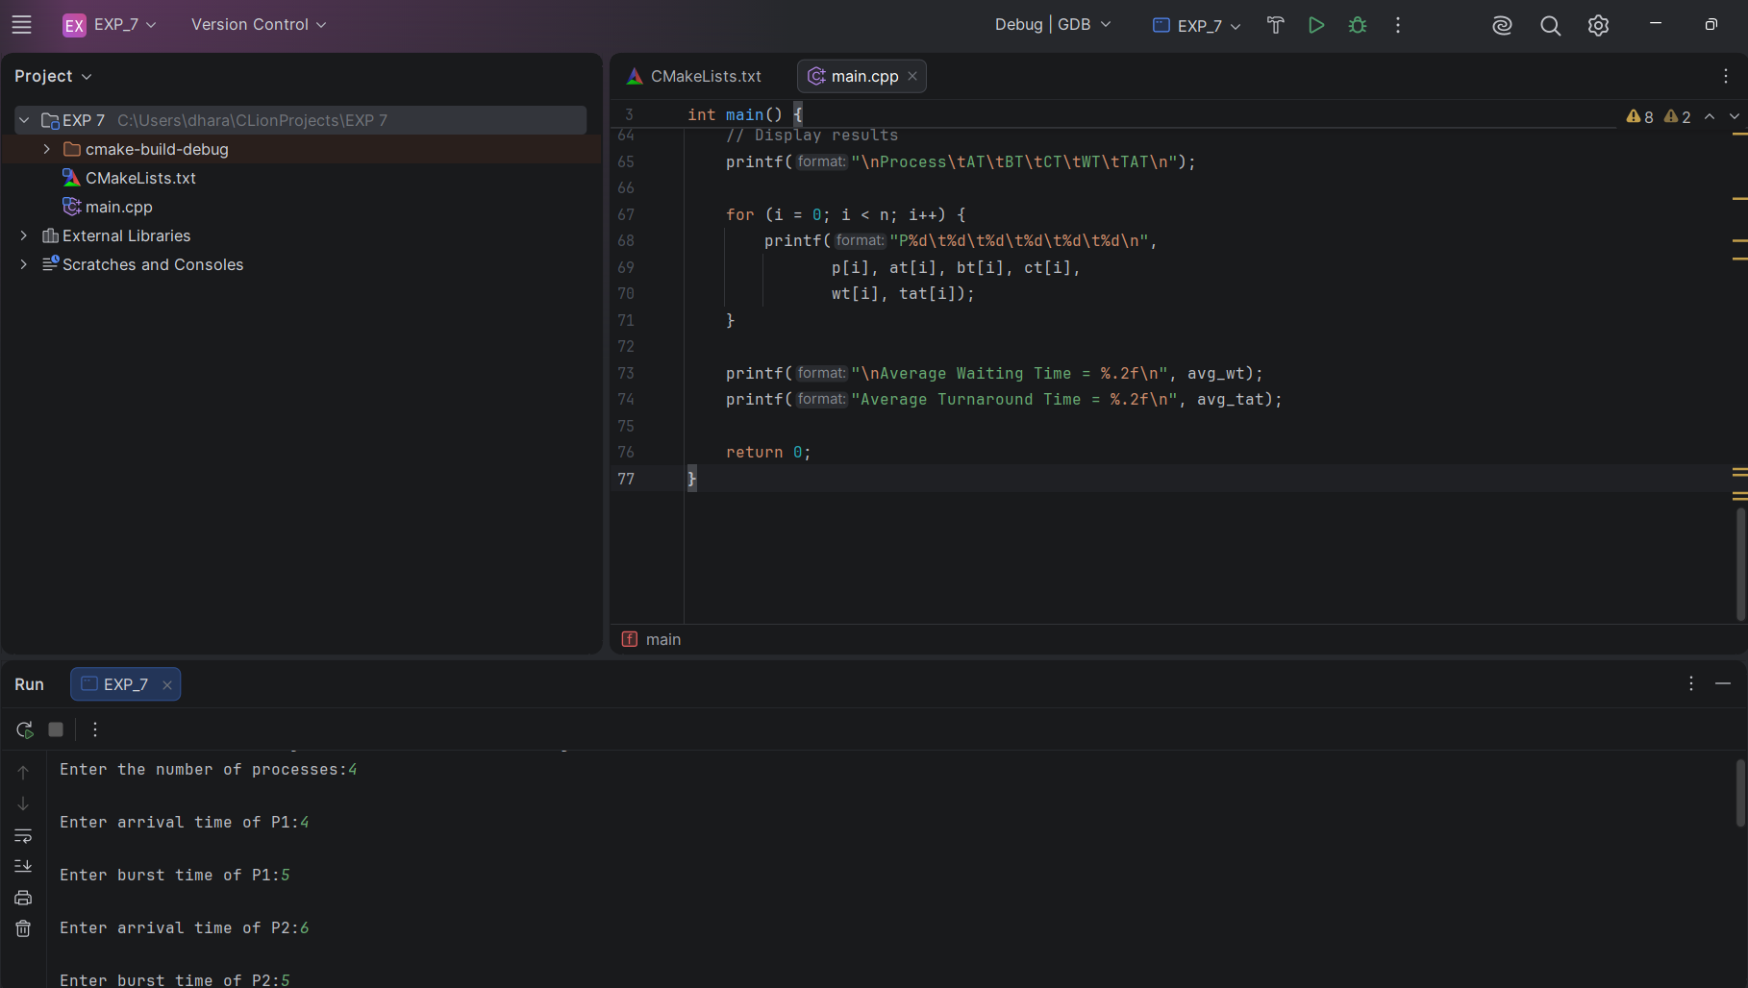
8. Construct a C program to simulate Round Robin scheduling algorithm with C.
#include <stdio.h>

int main() {
int n, i, quantum, time = 0;
int bt[100], rt[100], wt[100], tat[100], ct[100];
int p[100];
float avg_wt = 0, avg_tat = 0;

printf("Enter the number of processes: ");
scanf("%d", &n);

// Input burst times
for (i = 0; i < n; i++) {
p[i] = i + 1;

printf("Enter burst time for P%d: ", p[i]);
scanf("%d", &bt[i]);

rt[i] = bt[i];
}

printf("Enter time quantum: ");
scanf("%d", &quantum);

if (quantum <= 0) {
printf("Time quantum must be positive.\n");
return 1;
}

// Round Robin scheduling
while (1) {
int done = 1;

for (i = 0; i < n; i++) {
if (rt[i] > 0) {
done = 0;

if (rt[i] > quantum) {
time += quantum;
rt[i] -= quantum;
} else {
time += rt[i];
rt[i] = 0;
ct[i] = time;
}
}
}

if (done)
break;
}

// Calculate waiting and turnaround times
for (i = 0; i < n; i++) {
tat[i] = ct[i];
wt[i] = tat[i] - bt[i];

avg_wt += wt[i];
avg_tat += tat[i];
}

avg_wt /= n;
avg_tat /= n;

// Display results
printf("\nProcess\tBurst Time\tWaiting Time\tTurnaround Time\n");

for (i = 0; i < n; i++) {
printf("P%d\t%d\t\t%d\t\t%d\n",
p[i], bt[i], wt[i], tat[i]);
}

printf("\nAverage Waiting Time = %.2f\n", avg_wt);
printf("Average Turnaround Time = %.2f\n", avg_tat);

return 0;
}
